|  |
| --- |
| PSI Procedure for Boot On San Failover/Failback |
| PSI Procedure – Boot On San Failover/Failback |
| Recipients: |
| Remarks : |

|  |  |  |  |
| --- | --- | --- | --- |
| Version No | Date | Author | Modification Type |
| v1.0 | 11-Nov-2021 | Thibaut Cache | Document Inception |
|  |  |  |  |
|  |  |  |  |
|  |  |  |  |

Table of Contents

1 Introduction 4

1.1 Objective 4

1.2 Scope 4

2 Technical Dependency 5

3 Pre Requisites 6

4 Standard Input 7

5 Pre-Checks 8

6 Pre-Activity Log 9

7 Execution Steps 10

8 Conditional Actions 11

9 Expected Output 12

10 Post Checks 13

11 Post Check Logs 14

12 Log Comparision 15

13 Validation Report 16

14 Error Handling 17

15 Post Execution Document Update 18

16 Roll Back 19

# Introduction

## Objective

The Objective of the document is to perform the Failover / Failback of HP VCEM Server Profile between two VC Domains Bay during the PSI exercise.

## Scope

The scope of this document is only limited to CATS Boot On San Physical Servers on HP Blade hardware.

# Technical Dependency

None

# Pre Requisites

* The confirmation from PSI team & Unix build team with respect to the final CI list for the Servers in scope.
* Access to Servers ILO, HP VCEM & Adhoc commands

4 Standard Input

None

5 Pre-Checks

Up to the 15th of November 2021, there are only two Boot On San servers in production:

|  |  |  |
| --- | --- | --- |
| **HDI** | **HDM** | **Description** |
| slmupd1mys22.zres.ztech | slmupd1mys22-PCA | 5083 -OAPP -- PE000066T -- heberge la base de données oapp |
| slmupd1tdc01 | slmupd1tdc01-PCA | 6101 - DWH -- BT013702 -- Acquisition de données -- Script Open |

Both their main hardware servers are in Chartres Diderot. (HDI)

Their backup hardware servers are in Chartres Dalembert. (HDM)

6 Pre-Activity Log

None

7 Execution Steps

## Boot On San PSI switch-over Action :- (ALLER)

### Intro

A Boot On San server have two hardware servers. One with basic server name which is up most of the time and an other with a server name like *-PCA, which is down except when there is a switch-over.

### Get info

Notes in case of trouble : (Mostly through GestISF)

Serial number for both Server hardware.

VLAN ID

IP

IP ILO

MAC Adress

WWN for SAN

Example :

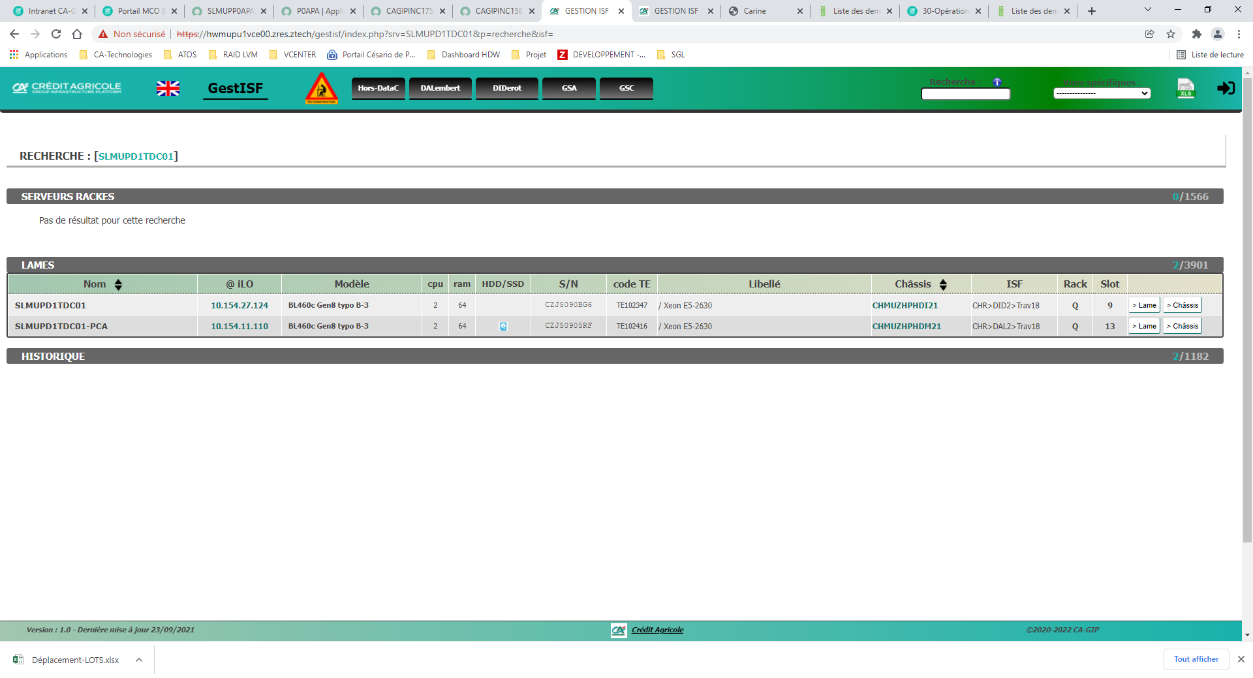

### Set nosup

Disable supervision for production server using the Zabbix monitoring portal.

**(**[**https://zabx-portail.prd.caas.ca-ts.group.gca**](https://zabx-portail.prd.caas.ca-ts.group.gca)**)**

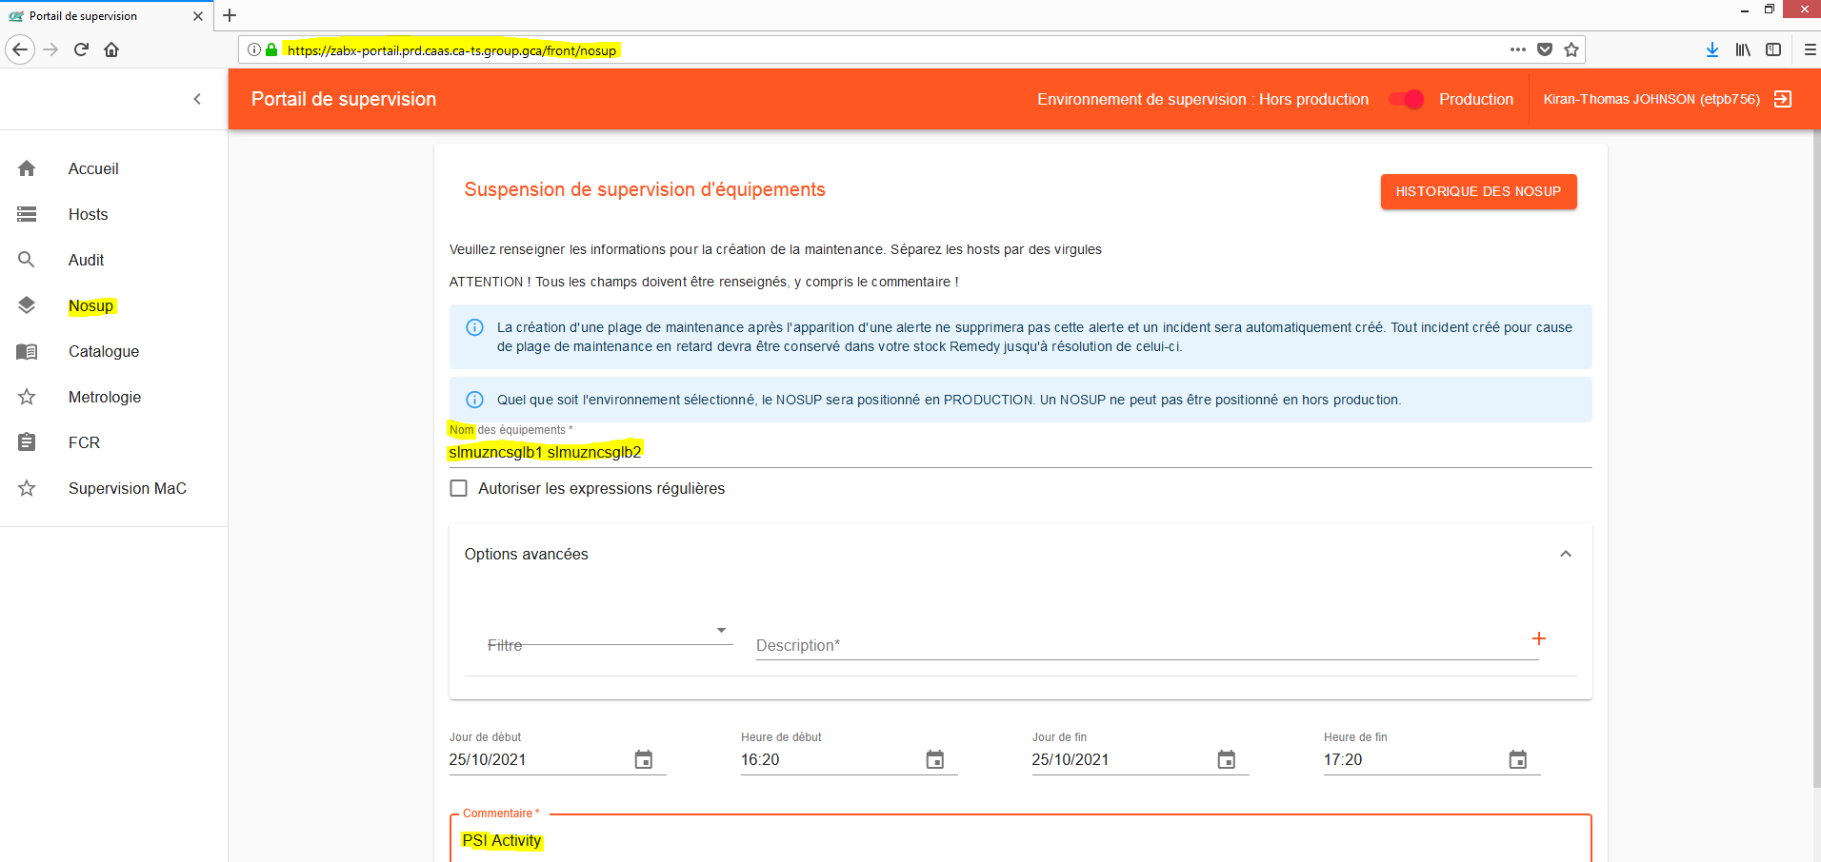

### Stop Server

shutdown –h now

### Move profile

In HP VCEM interface from main server hardware VC Domain to “PCA” server hardware VC Domain.

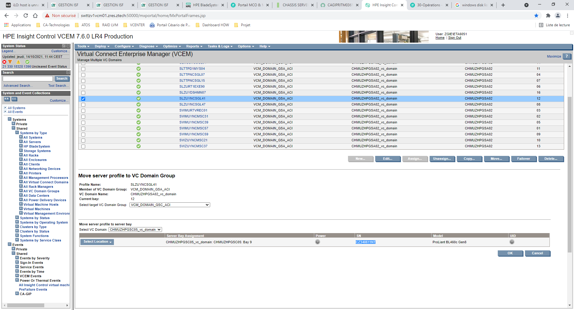

Sometimes, there will be an error message about the vlan name been different between the two VC Domain.

You have to put the right vlan after the Server Profile Move.

### Check info

Any error in VCEM ?

### Start Server

Using ILO interface on destination server. (The one with *-PCA name)

### Enable supervision

Delete the nosup or let it end.

### Proof taking

Screen shot from ILO console on the destination server .

**\*\*\*\*\*\*\*\*\*\*\*\*\*\*\*\*\*\*\*\*\*\*\*\*\*\*\*\*\*\*\*\*\*\*\*\*\*\*\*\*\*\*\*\*\*\*\*\*\*\*\*\*\*\*\*\*\*\*\*\*\*\*\*\*\*\*\*\*\*\*\*\*\*\*\*\*\*\*\*\*\*\*\*\*\*\*\*\*\*\*\*\*\*\*\*\*\*\*\*\*\*\*\*\*\*\*\*\*\*\*\*\*\*\*\*\*\*\*\*\*\*\*\*\*\*\***

## Boot On San PSI Rollback Action :- (RETOUR)

The same as 7.1 but you reverse the two servers order.

8 Conditional Actions

None

9 Expected Output

None

10 Post Checks

None

11 Post Check Logs

None

12 Log Comparision

None

13 Validation Report

None

14 Error Handling

None

15 Post Execution Document Update

None

16 Roll Back

None